Title of Your Paper

Paper ID:XX-XX

First Author (full first- and surname)

e-mail

Institution/Organization/College Name

City, Country

Co-author/s

e-mail

Institution/Organization/College Name

City, Country

**……..**

ABSTRACT

This document provides a template for writing papers for the IABSE Istanbul Symposium 2023. The proceedings will be published in an electronic format that will be available at the conference venue. The full paper is to be submitted in MS-Word format over EasyChair and written according to the instructions mentioned below.

**Full papers: 5-8 pages**

You should format your paper exactly like this document. The easiest way to do this is to download this template from the conference web pages and replace the content here with your text. The template file contains the required formatted styles so that you will not need to spend time formatting your paper. All relevant illustrations, tables, and equations can be correctly inserted following the examples in this template. The abstract should appear on the top of the first page, after the title of the paper under the heading given as ‘Abstract’. Under the title of the paper, details of the author(s) including email, name and institution name & place are to be given. The abstract of the full paper should be an explicit summary that relates the main research topic, the methodology, results, discussions and conclusions. Abstract and full paper should be single-spaced in 12-point type,and Times New Roman font. **Abstract should be one paragraph and less than 250 words.**

**Keywords:** Up to five keywords, 12-point type.

# INTRODUCTION

It is expected that authors will submit a carefully written and proofread material. Spelling and grammatical errors, as well as language usage problems, are expected to be avoided in the final submission. It is suggested that the paper length should be between 5 and 8 pages with a single-spaced 12-point type and Times New Roman font. Papers should be written in English, clearly describe the background of the subject, the authors work, including the methods used, and concluding discussion on the importance of the work.

# paper format

The uniform outlook will help the reader to follow the proceedings. This can be obtained most easily if authors use this template file to construct their papers. This template is in A4 format with 20

mm (0.8 inch) margins left, right, top and bottom. Header and footer shall be positioned 16 mm (0.65 inch) from the edge.

All text paragraphs should be single spaced, with the first line intended by 10 mm (0.4 inch). Double spacing should only be used before and after headings and subheadings as shown in this example. Position and style of headings and subheadings should follow this example. No spaces should be placed between paragraphs.

## Header, Footer, Page Numbering

If this template is used when writing the full paper, headers and footers will be set automatically.

## Fonts

The body of your paper should use 12-point Times New Roman font. The available styles available are bold, italic and underlined. It is recommended that text in figures not to be smaller than 9-point font size.

## Tables and Figures

Figure captions and table headings should be sufficient to explain the figure or table without the need to refer to the text. Figures and tables that are not cited in the text should not be presented.

The following is an example for the Tables.

Table 1 Title of Example Table

|  |  |  |  |  |  |  |  |  |
| --- | --- | --- | --- | --- | --- | --- | --- | --- |
| AAA | **Type X** | | | | **Type Y** | | | |
| Item1 | Item2 | Item3 | Item4 | Item1 | Item2 | Item3 | Item4 |
| BBB | 18 | 44 | 41 | 13 | 17 | 43 | 40. | 10 |
| CCC | 24 | 60. | 61 | 28 | 26 | 63 | 65 | 19 |

Tables and figures should be placed close to where it is first referred to in the text. All figures and tables should be numbered with Arabic numerals. Table headings should be centred above the tables. Figure captions should be centred below the figures.

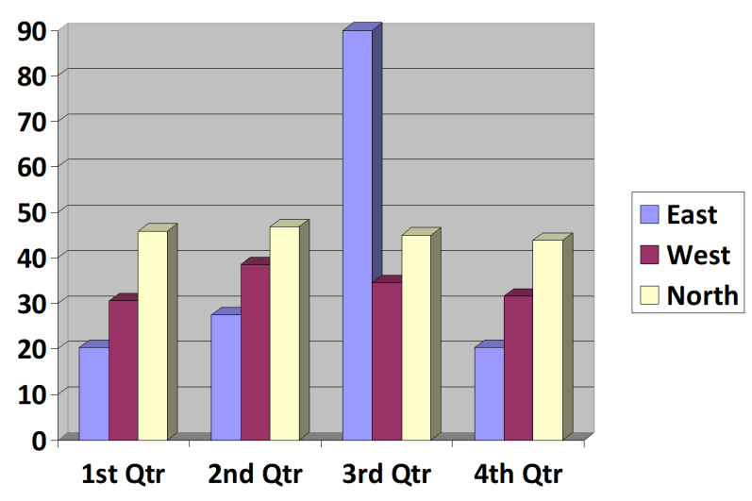

Figure 1: Caption of Example Figure

## Equations

Each equation should be presented on a separate line from the text with a blank space above and below. Equations should be clear and expressions used should be explained in the text. Type all equations. Flush the body of equation to left. Equations should be numbered in parentheses. Type equation numbers in Arabic numerals in parentheses. Example:

 (1)

# SUBMITTING THE Paper

The full papers have to be submitted electronically as instructed at the conference website. A Paper ID (in a particular format) will be assigned to each abstract after acceptance. Authors should place the paper ID to the correct position before submitting the final version of the paper.

# Conference Program and proceedings

Abstracts and full papers will be compiled into the Proceedings, which will be published electronically and made available to confirmed registrants of the conference.

# conclusion

Conclusions should state concisely the most important propositions of the paper as well as the author’s views of the practical implications of the results.

REFERENCES

Use 10-point Times New Roman font for the references and list them at the end of the paper. Include the following information (as applicable).

1. For a book: author(s) last name, name, (year). book title, page or chapter numbers, publisher, city.
2. For a journal paper: author(s) last name, name, (year). paper title (in quotes), journal name, volume and issue numbers, page numbers (inclusive).
3. For a proceedings paper or chapter in an edited book: author(s) last name, name, (year). paper or chapter title (in quotes), volume title, editor(s), volume number (if applicable), publisher, city, page numbers (inclusive).
4. An **in-text citation** (e.g.: Author last name, Year) appears in parentheses within the text of a paper, in order to indicate that a source is being cited. For one author refer as Bernt (2019), for 2 authors refer as Wener and Taby (2019) and 3 or more authors refer as Kronis et al. (2019). Every in-text citation must correspond to a reference at the end of the paper.
5. References must be listed in alphabetical order according to the **Last Name** of the first author and not numbered.